 **LiveLab** | UNDP Accelerator Labs

**INTRODUCTION:** The UNDP Accelerator Labs are a network of experimental and innovative units established by the United Nations Development Programme (UNDP) in 2019. Their primary objective is to drive progress towards achieving the Sustainable Development Goals (SDGs) more effectively and efficiently.

Here’s a call-to-action from the UNDP: Help us to showcase the value of grassroots innovation! We need easy to understand, yet powerful visualizations of the energy solutions we discovered that help us advocate for a more sustainable future. You’ll use Tableau to answer this call-to-action!

**HOW IT WORKS:** Follow the prompts in the questions below to investigate your data. [**Here’s that link**](https://prod-useast-b.online.tableau.com/#/site/globaltech/workbooks/805994?:origin=card_share_link) to your Tableau Cloud workbook, where you’ll create all the visualizations for this Lab! If you’re feeling up to it, you can use the **purple boxes** in this document for your visualizations. No need to submit this document to your Global Tech Team – it’s just for you!

**—** Data Set **Description**

You’ll find the following variables relevant for your visualizations.

contribution_date: Date of data record.

id: Unique identifier of the data entry.

Energy source: Source of energy used.

Clean cooking application: Application of clean cooking technology.

title: Title or name of the solution.

country: Country where the solution is applicable.

country_code: Code representing the country.

region: Geographic region of the solution.

Purpose: Brief description of the problem and solution.

Primary SDG goal: Main Sustainable Development Goal addressed.

SDG (tag n): Name of the nth Sustainable Development Goal addressed by the solution.

**— Task 1:** Where are the solutions coming from?

Better yet, what is their distribution per region? On **Sheet 1** of your workbook, create a bar chart to show the total number of solutions in each of the five regions. In which region are there the most solutions? In which regions are there the fewest?

**HINT:** Start by dragging the energy_sol_data.csv (Count) pill to the Columns and the Region pill to the Rows. Then look for the sort button

| (paste your visualization screenshot here) |
| --- |

**— Task 2:** Energy Source Type

What type of energy source is more prevalent, what is less? Are there differences per region, and why? On **Sheet 2** of your workbook, create another bar chart to show the total number of solutions by energy source and region.

**HINT:** Start by dragging the energy_sol_data.csv (Count) pill to the Columns and the Energy source pill to the Rows. Add the Region pill to the Rows, too.

| (paste your visualization screenshot here) |
| --- |

**— Task 3:** Sustainable Development Goals

What type of energy source is more prevalent, what is less? Are there differences per region, and why? On Sheet 2 of your workbook, create another bar chart to show the total number of solutions by energy source and region.

1. Which Sustainable Development Goals are the solutions advancing in particular, and how? On **Sheet 3** of your workbook, create a bar chart to show the total number of solutions advancing each of the 17 SDGs.

**HINT:** You’ll need to use the primary SDG pill here!

| (paste your visualization screenshot here) |
| --- |

1. How many Sustainable Development Goals are the solutions advancing *simultaneously*? You’ll need a calculated field here! Create one called number SDGs that assigns a label based on the number of non-null SDG tags.

* If SDG (tag1) is null, it labels it as "Unknown."
* If SDG (tag2) is null, it is labeled “1 SDG”.
* If SDG (tag3) is null, it is labeled “2 SDGs”.
* If SDG (tag4) is null, it is labeled “3 SDG”.
* If SDG (tag5) is null, it is labeled “4 SDG”.
* Otherwise, it is labeled as “Five or more SDGs”

Once you have this calculated field, use **Sheet 4** to create another (!!) bar chart illustrating the *distribution* of solutions based on the number of Sustainable Development Goals (SDGs) they are associated with.

**HINT:** You can use number SDGs in the Rows & Columns! Change the Rows to be a Measure → Count

| (paste your visualization screenshot here) |
| --- |

**— Task 4:** Clean Cooking Solutions

Looking at the use case of clean cooking solutions, what is their prevalence, distribution, and source of energy?

1. Clean cooking application is a *boolean* variable. Because we’re after the *proportion* of solutions that have a clean cooking application, create a calculated field called Clean cooking INT that returns a 1 if Clean cooking application is TRUE and a 0 otherwise.
2. Use this Clean cooking INT field in your final bar chart on **Sheet 5** that shows the proportion of solutions that have a clean cooking application by energy source. Filter your chart so you see the top 3 energy sources. What are they?

**HINT:** You’ll need to change the Measure on the Clean cooking INT pill in the Columns to be Average.

| (paste your visualization screenshot here) |
| --- |

1. **LevelUp:** On **Sheet 6**, see if you can recreate the following image.

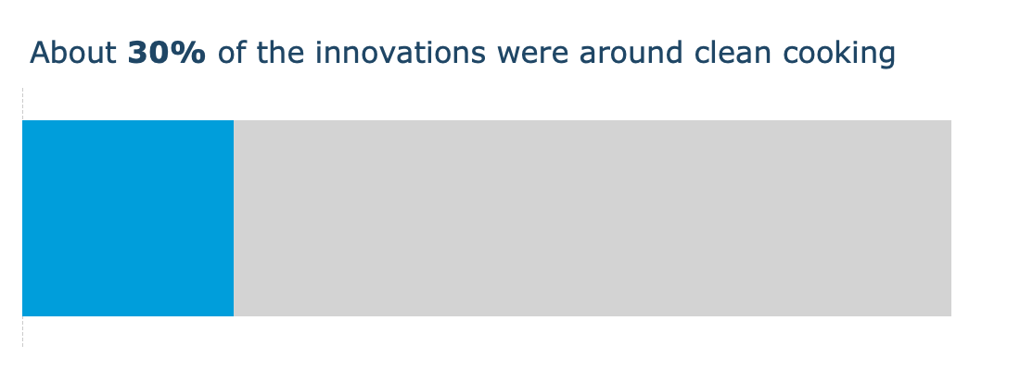

**HINT:** Start by dragging the pill Clean cooking application pill to the Rows & Columns. Change the Columns to be a Measure → Count and drag the Clean cooking application from the Rows to the Colors.

**— LevelUp:** Where are the solutions coming from (again)?

If your Team has extra time, use the **LevelUp** **Sheet** to recreate the following choropleth.

